**NAME: SYED LABIB**

**ID: 63896**

**COURSE: Web Development LAB**

**Program: BSSE**

OEL (Mid Term)

Submission Date: 2-DEC-2025

Submission Day: Tuesday

Submitted To: Miss Urooj Fatima

***Question 1:***

As a Web developer, you are required to show how an error in Visual Studio is identified using debugging tool. Also, Explain How does Visual Studio IntelliSense suggest code completions.

**ANS: Identifying an Error Using Visual Studio Debugging**

1. Run the program with **F5**.
2. When an error occurs, Visual Studio stops at the exact line causing the issue.
3. The **yellow arrow** and **error message** show the exception type and details.
4. Use **Locals**, **Watch**, and **Call Stack** to inspect variable values and find the root cause.
5. Fix the code and re-run.

**How IntelliSense Suggests Code Completions**

1. IntelliSense analyzes your code in real time.
2. When you type a keyword or a dot (.), it shows a dropdown of valid methods, properties, and variables.
3. Suggestions are context-aware—based on the object, scope, and imported namespaces.
4. Tooltips show parameters and descriptions, helping you write correct code quickly.

# ***QUESTION 2:*** You are required to replicate an Ecommerce Website Using HTML, CSS, Bootstrap, JavaScript, JQuery. **E-Commerce Website Replication:**

Link of Website: [click here](https://www.thesusoutdoors.com/)

Title of Website:  
 **Thesus Outdoors** *footwear brand (boots only)*

**Problem Statement:**

To develop a fully responsive front-end replica of the e-commerce platform “ThesusOutdoors.com” using HTML, CSS, Bootstrap, JavaScript, and jQuery, with the objective of accurately reproducing its product catalog layout, navigation structure, filtering components, visual design language, and user interface behaviors, while intentionally excluding all backend or server-side functionality.

**Deliverables:**  
• Functional front-end replica of ThesusOutdoors.com  
• Website link (live demo)  
• Source code folder (HTML, CSS, JS, assets)  
• Screenshots of the interface, filters, and responsive layouts  
• Documentation report describing project scope and deliverables

**Required Tools:**  
• HTML5  
• CSS3  
• Bootstrap 5  
• JavaScript   
• jQuery  
• VS Code

Screenshots of Code:

Index.html:  
  
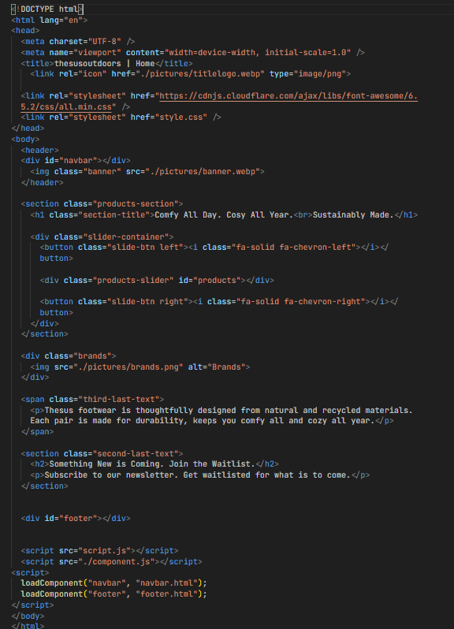  
  
Footer.html:  
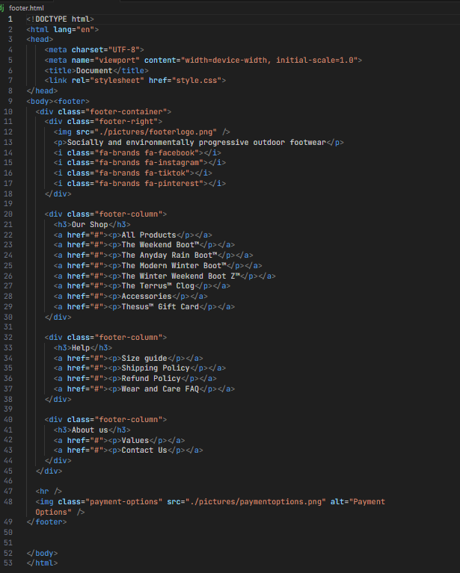

ABOUTUS.html  
  
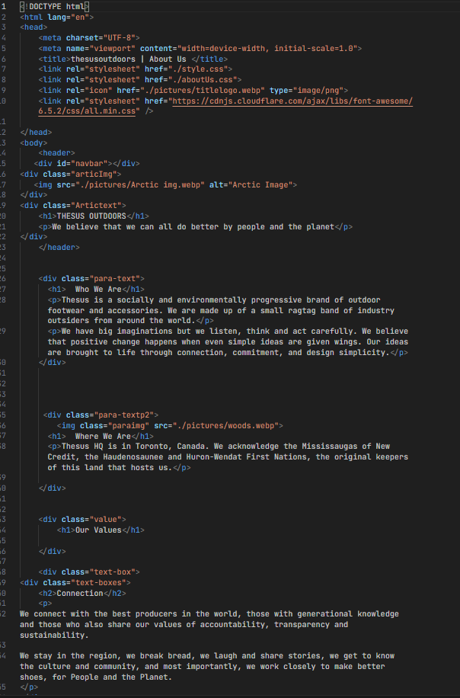  
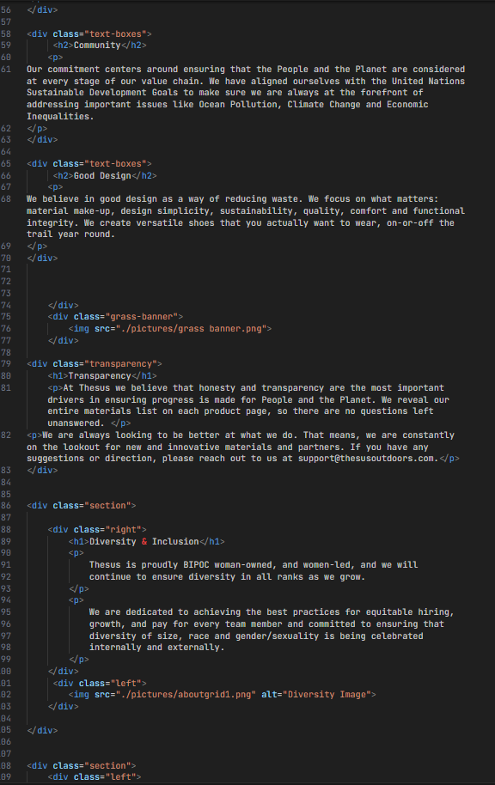  
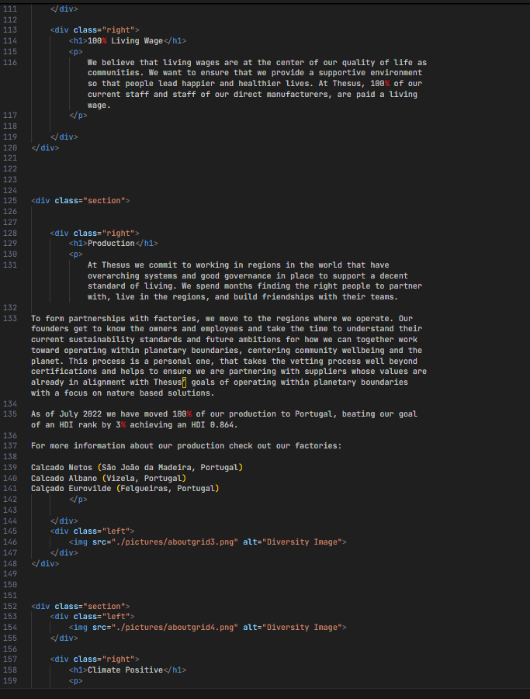  
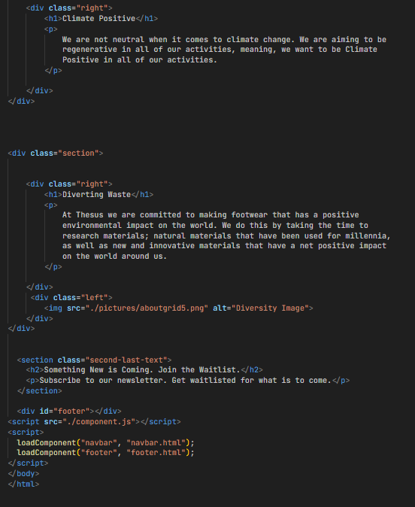  
  
NAVBAR.html  
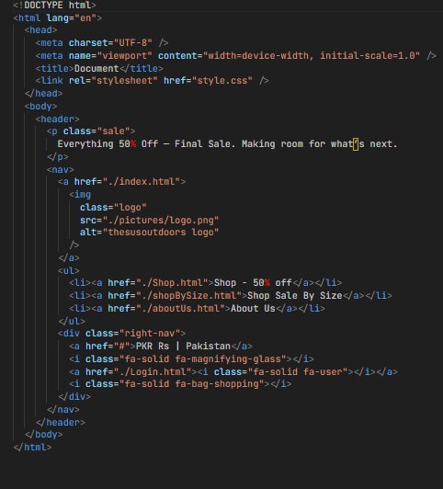  
  
ProductDetail.html:  
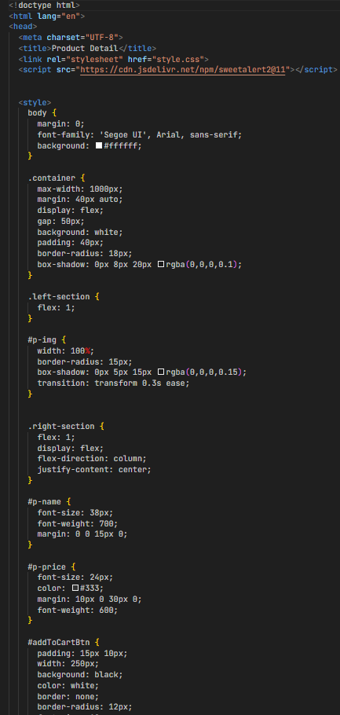  
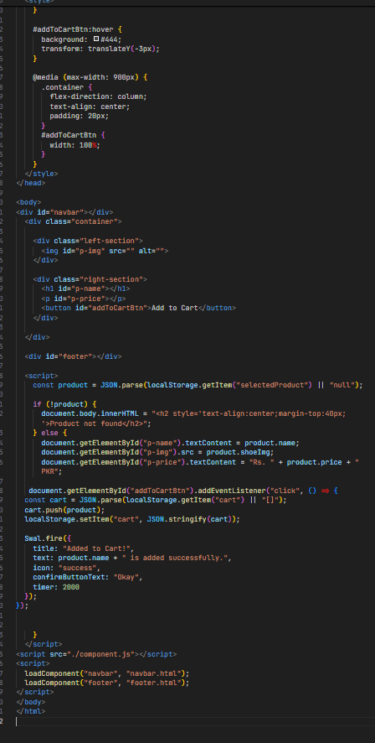  
Shop.html:  
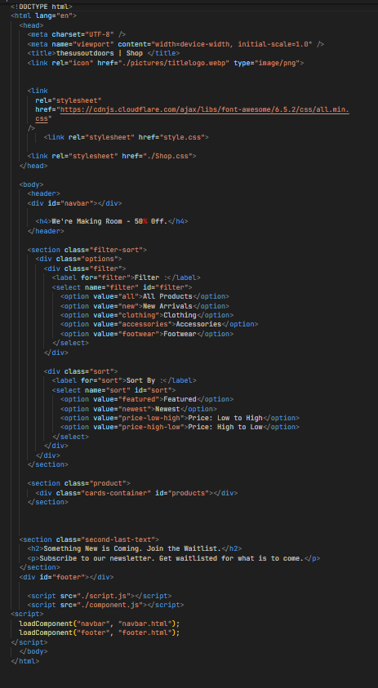  
   
ShopbySize.html:  
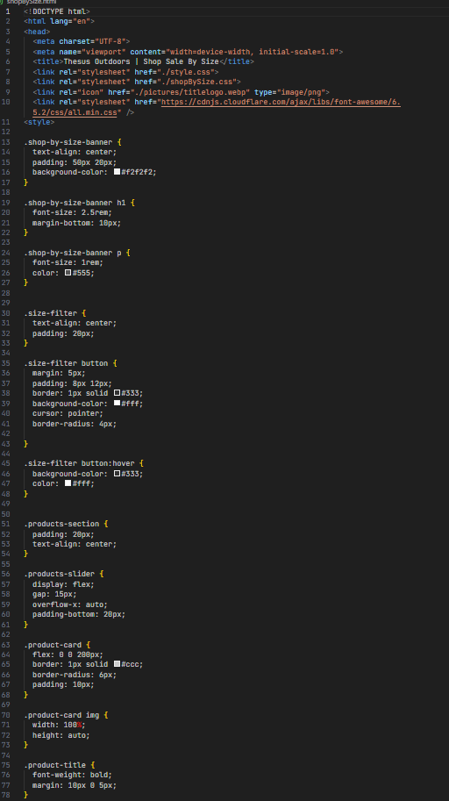  
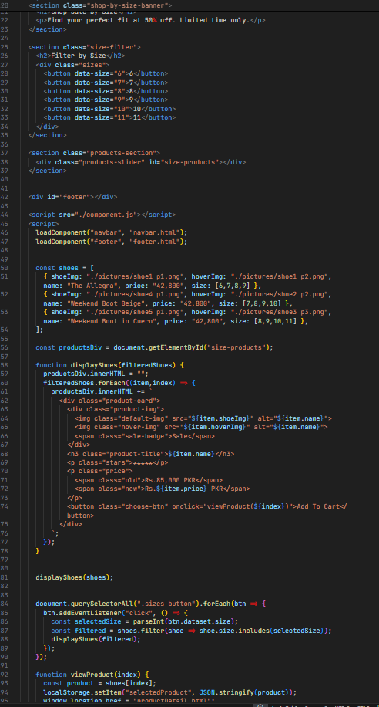  
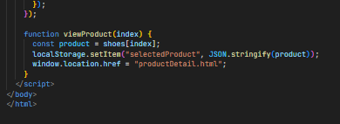  
Login.html:  
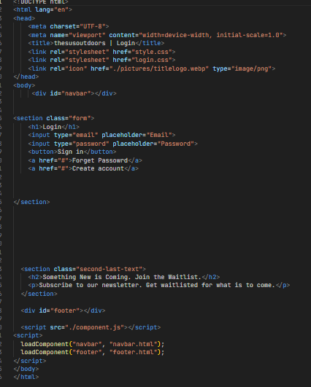  
  
CSS files:  
  
ABOUTUS.css

|  |
| --- |
| * {    margin: 0;    padding: 0;  }  .articImg img {    width: 100%;    display: block;    filter: brightness(70%);    height: 60vh;  }  .Artictext {    position: absolute;    top: 50%;    left: 50%;    transform: translate(-50%, -50%);    text-align: center;    color: white;  }  .para-text {    margin-top: 50px;  }  .para-text h1 {    text-align: center;    color: rgb(2, 46, 2);  }  .para-text p {    text-align: center;    margin-top: 20px;    margin-bottom: 20px;    color: rgb(2, 46, 2);  }  .paraimg {    width: 100%;  }  .para-textp2 {    position: relative;    }  .para-textp2 img {   height: 40vh;    }  .para-textp2 h1 {    position: absolute;    text-align: center;    top: 50%;    left: 50%;    transform: translate(-50%, -50%);    color: white;  }  .para-textp2 p {    position: absolute;    text-align: center;    top: 55%;    left: 50%;    transform: translate(-50%, -50%);    color: white;    margin-top: 20px;  }  .grass-banner img{      width: 100%;      height: 40vh;      margin-bottom: 30px;  }  .value {    text-align: center;    margin-top: 20px;  }  .text-box {    display: flex;    justify-content: space-between;    flex-direction: row;    gap: 20px;    margin-top: 40px;  }  .text-boxes h2 {    align-items: center;  }  .text-boxes p {    align-items: center;    line-height: 40px;    margin-bottom: 50px;  }  .transparency{      text-align: center;      margin-bottom: 90px;  }  .transparency p{    margin-top: 20px;  }    .section {      display: flex;      align-items: center;      justify-content: center;      gap: 60px;      padding: 60px 80px;  }  .section .left img {      width: 450px;      height: auto;      border-radius: 10px;      object-fit: cover;    }  .section .right {      max-width: 600px;  }  .section .right h1 {      font-size: 42px;      font-weight: 600;      margin-bottom: 20px;      color: #0d3025;  }  .section .right p {      font-size: 18px;      line-height: 1.7;      color: #444;  }    .second-last-text {    text-align: center;        color: rgb(1, 38, 1);    background-color: rgb(233, 230, 230);    padding: 150px;  }  .second-last-text h2 {    font-size: 40px;    font-weight: lighter;    margin-bottom: 20px;  }  .second-last-text p {    font-size: 20px;  }    @media (max-width: 1100px) {    .section {      flex-direction: column;      padding: 50px 40px;      gap: 40px;    }    .section .left img {      width: 100%;      max-width: 400px;    }    .section .right {      max-width: 100%;    }    .text-box {      flex-direction: column;      gap: 20px;    }    .text-boxes p {      line-height: 32px;    }    .para-textp2 img {      height: 35vh;    }  }  @media (max-width: 850px) {    .Artictext {      top: 45%;    }    .para-textp2 h1,    .para-textp2 p {      font-size: 18px;    }    .para-textp2 img {      height: 30vh;    }    .grass-banner img {      height: 30vh;    }    .section .right h1 {      font-size: 32px;    }    .section .right p {      font-size: 16px;    }    .text-boxes h2 {      font-size: 20px;    }    .text-boxes p {      line-height: 28px;    }  }  @media (max-width: 650px) {    .Artictext {      font-size: 14px;      padding: 0 10px;    }    .section {      padding: 40px 20px;      gap: 30px;    }    .section .right h1 {      font-size: 28px;    }    .section .right p {      font-size: 15px;    }    .text-boxes h2 {      font-size: 18px;    }    .text-boxes p {      font-size: 14px;      line-height: 24px;    }    .para-textp2 h1,    .para-textp2 p {      font-size: 16px;    }    .para-textp2 img {      height: 25vh;    }    .grass-banner img {      height: 25vh;    }    .second-last-text {      padding: 100px 20px;    }    .second-last-text h2 {      font-size: 30px;    }    .second-last-text p {      font-size: 16px;    }  }  @media (max-width: 480px) {    .section {      padding: 30px 15px;      gap: 20px;    }    .section .right h1 {      font-size: 24px;    }    .section .right p {      font-size: 14px;    }    .text-boxes h2 {      font-size: 16px;    }    .text-boxes p {      font-size: 13px;      line-height: 22px;    }    .para-textp2 h1,    .para-textp2 p {      font-size: 14px;    }    .para-textp2 img {      height: 20vh;    }    .grass-banner img {      height: 20vh;    }    .second-last-text {      padding: 80px 15px;    }    .second-last-text h2 {      font-size: 24px;    }    .second-last-text p {      font-size: 14px;    }  }  @media (max-width: 350px) {    .section .right h1 {      font-size: 20px;    }    .section .right p {      font-size: 12px;    }    .text-boxes h2 {      font-size: 14px;    }    .text-boxes p {      font-size: 12px;      line-height: 20px;    }    .para-textp2 h1,    .para-textp2 p {      font-size: 12px;    }    .second-last-text h2 {      font-size: 20px;    }    .second-last-text p {      font-size: 12px;    }  } |

Login.css

|  |
| --- |
| * {    margin: 0;    padding: 0;    box-sizing: border-box;  }  .form {    height: 100vh;    display: flex;    justify-content: center;    align-items: center;    flex-direction: column;    gap: 20px;    font-family: Arial;    margin-bottom: -250px;    margin-top: -200px;  }  .form h1 {    color: green;  }  .form input {    padding: 10px 20px;    width: 250px;    border-radius: 10px;    border: 1px solid gray;    font-size: 16px;  }  button {    background-color: rgb(6, 65, 6);    color: white;    padding: 12px 25px;    border-radius: 15px;    border: none;    cursor: pointer;    font-size: 16px;  }  button:hover {    background-color: rgb(4, 50, 4);  }  .form a {    color: rgb(6, 65, 6);    text-decoration: none;    font-size: 14px;  }  @media (max-width: 1100px) {    .form {      width: 80%;      margin-top: -100px;    }    .form input {      width: 220px;      padding: 10px 18px;      font-size: 15px;    }    button {      padding: 10px 22px;      font-size: 15px;    }  }  @media (max-width: 850px) {    .form {      width: 70%;      margin-top: -50px;    }    .form input {      width: 200px;      padding: 10px 15px;      font-size: 14px;    }    button {      padding: 10px 20px;      font-size: 14px;    }    .form a {      font-size: 13px;    }  }  @media (max-width: 650px) {    .form {      width: 90%;      margin-top: 0;      gap: 15px;    }    .form input {      width: 100%;      padding: 12px 15px;      font-size: 14px;    }    button {      width: 100%;      padding: 12px 0;      font-size: 14px;    }    .form a {      font-size: 12px;    }  }  @media (max-width: 480px) {    .form {      width: 95%;      margin-top: 0;      gap: 12px;    }    .form h1 {      font-size: 24px;    }    .form input {      font-size: 13px;      padding: 10px 12px;    }    button {      font-size: 13px;      padding: 10px 0;    }    .form a {      font-size: 11px;    }  }  @media (max-width: 350px) {    .form h1 {      font-size: 20px;    }    .form input {      font-size: 12px;      padding: 8px 10px;    }    button {      font-size: 12px;      padding: 8px 0;    }    .form a {      font-size: 10px;    }  } |

Shop.css:

|  |
| --- |
| * {    margin: 0;    padding: 0;    box-sizing: border-box;  }  .sale {    background-color: rgb(2, 45, 2);    text-align: center;    color: white;    padding: 10px;    font-weight: 500;  }  h4 {    color: rgb(4, 53, 4);    font-size: 40px;    font-weight: 200;    margin-left: 70px;    margin-top: 20px;  }  .options {    display: flex;    justify-content: space-between;    margin-left: 65px;    margin-right: 60px;    margin-top: 30px;  }    .product {    padding: 30px 50px;  }  .cards-container {    display: grid;    grid-template-columns: repeat(4, 1fr);    gap: 30px;  }  .product-card {    border: 1px solid #ddd;    padding: 15px;    border-radius: 6px;    text-align: center;    transition: 0.3s;  }  .product-card:hover {    box-shadow: 0px 5px 18px rgba(0, 0, 0, 0.15);  }  .product-img {    width: 100%;    height: 250px;    background: #f2f2f2;    position: relative;    border-radius: 5px;    overflow: hidden;  }  .product-img img {    width: 100%;    height: 100%;    object-fit: cover;  }  .sale-badge {    position: absolute;    bottom: 10px;    left: 10px;    background: #a8a8a8;    color: white;    padding: 4px 10px;    border-radius: 15px;    font-size: 12px;  }  .product-title {    margin: 15px 0 5px;    font-size: 16px;    font-weight: 600;  }  .stars {    color: #ffb400;    margin: 5px 0;  }  .price {    margin: 10px 0;  }  .price .old {    text-decoration: line-through;    color: #999;    margin-right: 10px;  }  .price .new {    color: #0a3b2b;    font-weight: 700;  }  .choose-btn {    width: 100%;    padding: 10px;    border: 2px solid #0a3b2b;    border-radius: 5px;    background: white;    cursor: pointer;    font-size: 14px;    transition: 0.3s;  }  .choose-btn:hover {    background: #0a3b2b;    color: white;  }  @media (max-width: 1100px) {    .cards-container {      grid-template-columns: repeat(2, 1fr);    }  }  @media (max-width: 650px) {    .cards-container {      grid-template-columns: 1fr;    }    .filter-sort {      flex-direction: column;      gap: 20px;    }  }    @media (max-width: 1100px) {    h4 {      font-size: 32px;      margin-left: 40px;    }    .options {      margin-left: 40px;      margin-right: 40px;    }    .cards-container {      grid-template-columns: repeat(2, 1fr);    }  }  @media (max-width: 850px) {    nav {      flex-direction: column;      gap: 15px;      padding-bottom: 20px;    }    ul {      flex-direction: row;      gap: 20px;    }    h4 {      text-align: center;      margin-left: 0;    }    .options {      flex-direction: column;      gap: 15px;      margin-left: 20px;      margin-right: 20px;    }    .cards-container {      grid-template-columns: repeat(2, 1fr);    }    .product-img {      height: 230px;    }  }  @media (max-width: 650px) {    h4 {      font-size: 28px;    }    .cards-container {      grid-template-columns: 1fr;    }    .product-img {      height: 220px;    }    .options {      margin-left: 15px;      margin-right: 15px;    }    nav ul {      flex-direction: column;      gap: 10px;    }  }  @media (max-width: 480px) {    .sale {      font-size: 13px;      padding: 8px;    }    h4 {      font-size: 24px;    }    nav img.logo {      width: 120px;    }    .right-nav {      font-size: 13px;      gap: 8px;    }    .product-img {      height: 200px;    }    .product-card {      padding: 10px;    }    .product-title {      font-size: 14px;    }    .choose-btn {      padding: 8px;      font-size: 13px;    }    .options {      margin-left: 10px;      margin-right: 10px;    }  }  @media (max-width: 350px) {    h4 {      font-size: 20px;    }    nav img.logo {      width: 100px;    }    .product-img {      height: 180px;    }    .choose-btn {      font-size: 12px;      padding: 7px;    }  } |

style.css:

|  |
| --- |
| * {    margin: 0;    padding: 0;    box-sizing: border-box;  }  .sale {    background-color: rgb(2, 45, 2);    text-align: center;    color: white;    margin-bottom: 20px;    padding: 10px;  }  nav {    display: flex;    justify-content: space-between;    border-bottom: 1px solid lightgrey;    padding-bottom: 30px;  }  .logo {    width: 150px;    height: 60px;    margin-left: 56px;  }  ul {    display: flex;    gap: 40px;    list-style: none;    padding-top: 30px;  }  ul a {    text-decoration: none;    color: black;    font-size: 18px;    font-weight: 200;  }  ul a:hover {    text-decoration: underline;  }  .right-nav {    display: flex;    gap: 20px;    margin-right: 20px;    padding-top: 30px;  }  .right-nav a {    text-decoration: none;    color: black;    font-size: 18px;    font-weight: 200;  }  .right-nav a:hover {    text-decoration: underline;  }  .banner {    width: 100%;    height: 80vh;    object-fit: cover;  }  .products-section {    padding: 40px 60px;    text-align: center;  }  .section-title {    font-size: 38px;    line-height: 1.4;    margin-bottom: 50px;    color: #0b3d2e;    font-weight: 600;  }  .slider-container {    position: relative;    display: flex;    align-items: center;  }  .products-slider {    display: flex;    overflow-x: auto;    scroll-behavior: smooth;    gap: 20px;    padding: 10px 0;  }  .products-slider::-webkit-scrollbar {    display: none;  }  .product-card {    min-width: 250px;    border: 1px solid #ddd;    padding: 15px;    border-radius: 6px;    transition: 0.3s;    flex-shrink: 0;  }  .product-card:hover {    box-shadow: 0px 5px 18px rgba(0, 0, 0, 0.15);  }  .product-img {    width: 100%;    height: 200px;    position: relative;    border-radius: 5px;    overflow: hidden;  }  .product-img img {    width: 100%;    height: 100%;    object-fit: cover;  }  .sale-badge {    position: absolute;    bottom: 12px;    left: 12px;    background: #a8a8a8;    color: #fff;    padding: 4px 12px;    border-radius: 15px;    font-size: 13px;  }  .product-title {    margin-top: 15px;    font-size: 17px;    font-weight: 600;  }  .stars {    color: #ffb400;    margin: 5px 0;  }  .reviews {    color: #333;  }  .price {    margin: 10px 0;  }  .price .old {    text-decoration: line-through;    margin-right: 10px;    color: #999;  }  .price .new {    color: #0a3b2b;    font-weight: 700;  }  .choose-btn {    width: 100%;    padding: 12px;    border: 2px solid #0a3b2b;    border-radius: 5px;    background: white;    cursor: pointer;    font-size: 15px;    transition: 0.3s;  }  .choose-btn:hover {    background: #0a3b2b;    color: white;  }  .slide-btn {    position: absolute;    top: 50%;    transform: translateY(-50%);    background: rgba(0, 0, 0, 0.5);    color: white;    border: none;    padding: 10px;    cursor: pointer;    z-index: 10;    border-radius: 50%;  }  .slide-btn.left {    left: 0;  }  .slide-btn.right {    right: 0;  }  .brands img {    width: 100%;    margin: 50px 0;  }  .product-img {    position: relative;    overflow: hidden;  }  .product-img img {    width: 100%;    height: 100%;    object-fit: cover;    position: absolute;    top: 0;    left: 0;    transition: opacity 0.4s ease;  }  .default-img {    opacity: 1;  }  .hover-img {    opacity: 0;  }  .product-card:hover .default-img {    opacity: 0;  }  .product-card:hover .hover-img {    opacity: 1;  }  span p {    font-size: 22px;    text-align: center;    width: 60%;    margin: 30px auto 150px auto;    color: rgb(1, 50, 1);    font-weight: 500;  }  .third-last-text p {    color: #050505;    font-size: 50px;  }  .second-last-text {    text-align: center;    color: rgb(1, 38, 1);    background-color: rgb(233, 230, 230);    padding: 150px 20px;  }  footer {    background-color: #123026;    padding: 100px;  }  footer a {    color: white;    text-decoration: none;    line-height: 25px;  }  footer a:hover {    text-decoration: underline;  }  .footer-right p,  .footer-column p,  .footer-column h3 {    color: white;  }  footer hr {    margin-top: 25px;  }  .footer-right i {    margin-top: 15px;    color: white;  }  .footer-container {    display: flex;    justify-content: space-between;    gap: 40px;  }  .payment-options {    display: block;    margin: 40px auto 0 auto;  }  @media (max-width: 800px) {    .products-slider {      gap: 15px;    }    .product-card {      min-width: 200px;    }  }  @media (max-width: 480px) {    nav {      flex-direction: column;      align-items: center;      padding-bottom: 20px;    }    .logo {      margin-left: 0;      width: 120px;      height: auto;    }    ul {      flex-direction: column;      gap: 15px;      padding-top: 10px;    }    .right-nav {      padding-top: 15px;    }    .banner {      height: 40vh;    }    .section-title {      font-size: 26px;    }    .product-card {      min-width: 180px;    }    span p {      font-size: 16px;      width: 90%;      margin-top: 20px;    }    .third-last-text p {      font-size: 26px;    }    footer {      padding: 40px;    }    .footer-container {      flex-direction: column;      text-align: center;      gap: 30px;    }    .payment-options {      width: 90%;    }  }  @media (max-width: 768px) {    nav {      padding-bottom: 20px;    }    ul {      gap: 20px;    }    .banner {      height: 50vh;    }    .section-title {      font-size: 30px;    }    .product-card {      min-width: 200px;    }    span p {      width: 80%;      font-size: 20px;    }    footer {      padding: 60px;    }    .footer-container {      flex-direction: column;      text-align: center;      gap: 40px;    }  }  @media (max-width: 1024px) {    ul {      gap: 25px;    }    .banner {      height: 60vh;    }    .product-card {      min-width: 230px;    }    footer {      padding: 70px;    }    .footer-container {      flex-direction: column;      gap: 50px;    }  }  @media (max-width: 1280px) {    .logo {      width: 130px;    }    .section-title {      font-size: 34px;    }    .product-card {      min-width: 240px;    }    footer {      padding: 80px;    }  } |

JAVASCRIPT files:  
  
Components.js:

|  |
| --- |
| async function loadComponent(id, file) {    const container = document.getElementById(id);    if (container) {      const html = await fetch(file).then(res => res.text());      container.innerHTML = html;    }  } |

Script.js:

|  |
| --- |
| const shoeImages = [    { shoeImg: "./pictures/shoe1 p1.png", hoverImg: "./pictures/shoe1 p2.png", name: "The Allegra", price: "42,800" },    { shoeImg: "./pictures/shoe4 p1.png", hoverImg: "./pictures/shoe2 p2.png", name: "Weekend Boot Beige", price: "42,800" },    { shoeImg: "./pictures/shoe5 p1.png", hoverImg: "./pictures/shoe3 p3.png", name: "Weekend Boot in Cuero", price: "42,800" },    { shoeImg: "./pictures/shoe7 p1.png", hoverImg: "./pictures/shoe4 p2.png", name: "The Allegra", price: "42,800" },    { shoeImg: "./pictures/shoe6 p1.png", hoverImg: "./pictures/shoe1 p2.png", name: "Weekend Boot in Sage", price: "42,800" },    { shoeImg: "./pictures/shoe6 p1.png", hoverImg: "./pictures/shoe2 p2.png", name: "Weekend Boot Beige", price: "42,800" },    { shoeImg: "./pictures/shoe7 p1.png", hoverImg: "./pictures/shoe3 p3.png", name: "Weekend Boot in Cuero", price: "42,800" },    { shoeImg: "./pictures/shoe8 p1.png", hoverImg: "./pictures/shoe4 p2.png", name: "Weekend Boot in Sage", price: "42,800" }  ];  const productsDiv = document.getElementById("products");  shoeImages.forEach((item,index) => {    productsDiv.innerHTML += `      <div class="product-card">        <div class="product-img">          <img class="default-img" src="${item.shoeImg}" alt="${item.name}">          <img class="hover-img" src="${item.hoverImg}" alt="${item.name}">          <span class="sale-badge">Sale</span>        </div>        <h3 class="product-title">${item.name}</h3>        <p class="stars">★★★★★</p>        <p class="price">          <span class="old">Rs.85,000 PKR</span>          <span class="new">Rs.${item.price} PKR</span>        </p>        <button class="choose-btn" onclick="viewProduct(${index})">Add To Cart</button>      </div>    `;  });  const slider = document.querySelector(".products-slider");  const leftBtn = document.querySelector(".slide-btn.left");  const rightBtn = document.querySelector(".slide-btn.right");  rightBtn.addEventListener("click", () => slider.scrollLeft += 300);  leftBtn.addEventListener("click", () => slider.scrollLeft -= 300);    function viewProduct(index) {    const product = shoeImages[index];    localStorage.setItem("selectedProduct", JSON.stringify(product));      window.location.href = "productDetail.html";  } |

Screenshots of Output:

Landing Page:  
  
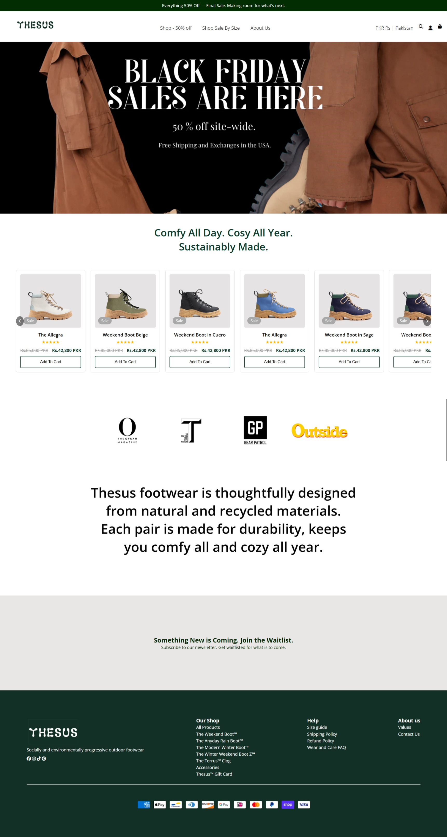

Shop:

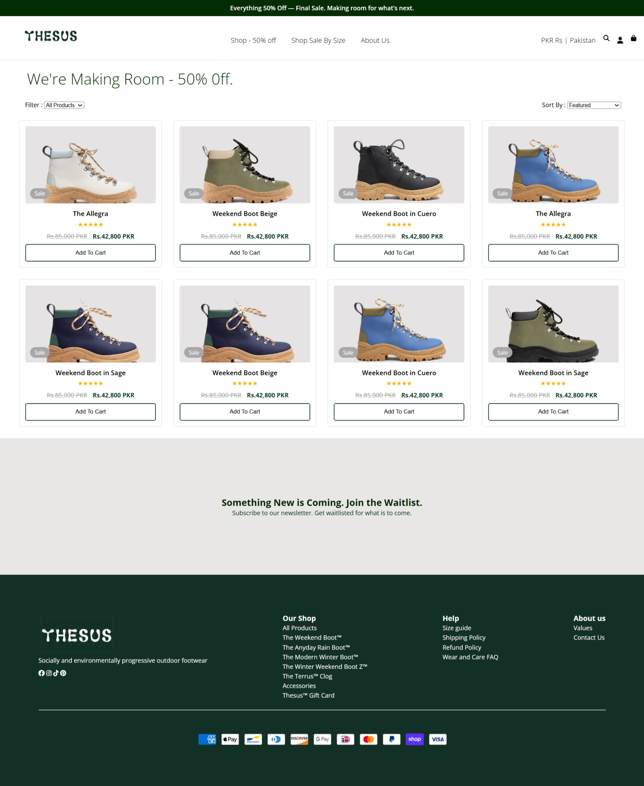

ABOUT page:  
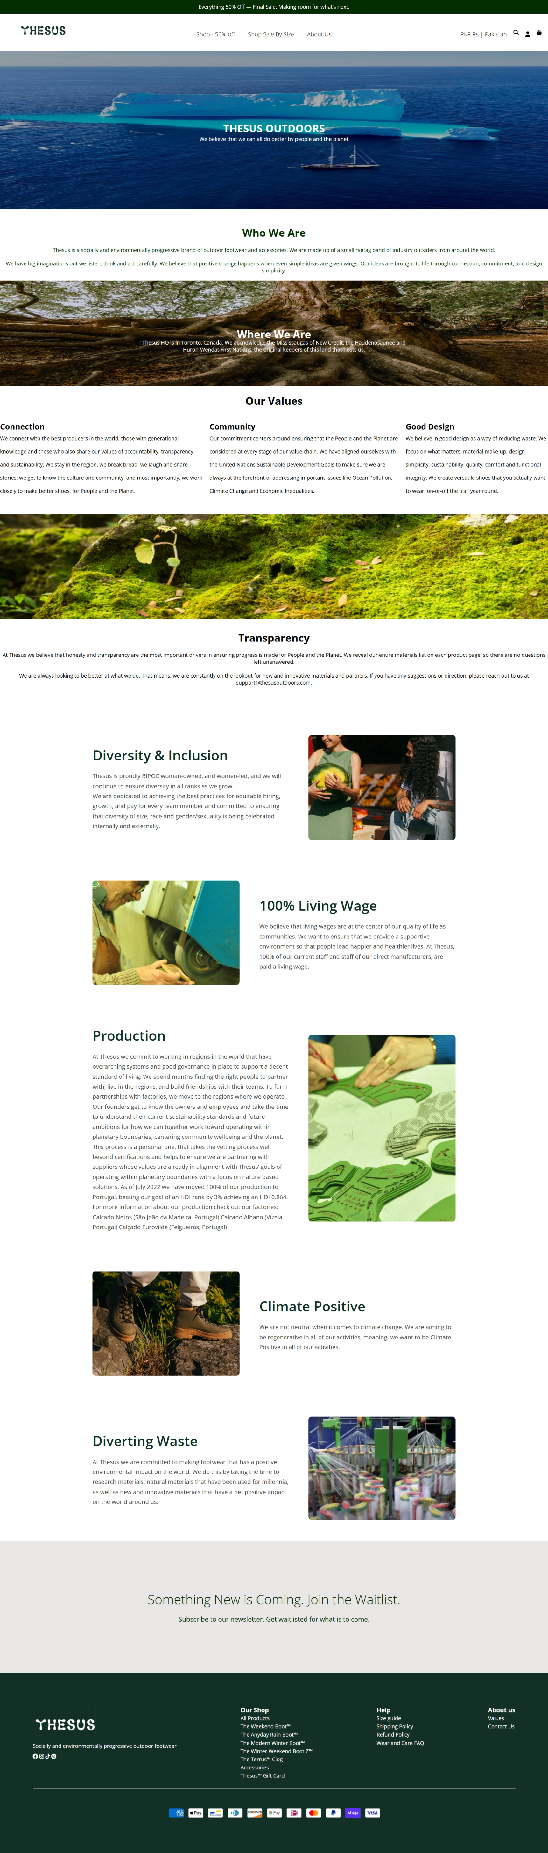  
  
  
Login Page:  
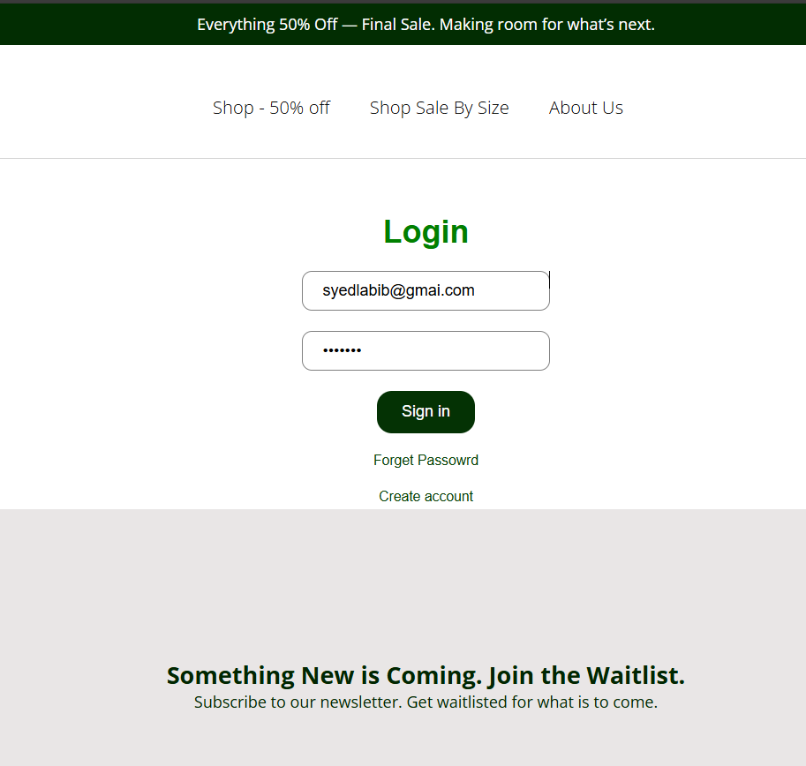  
  
**ADD TO CART:**  
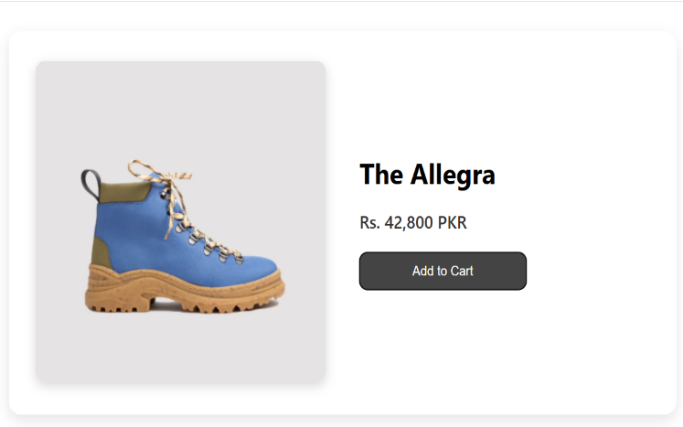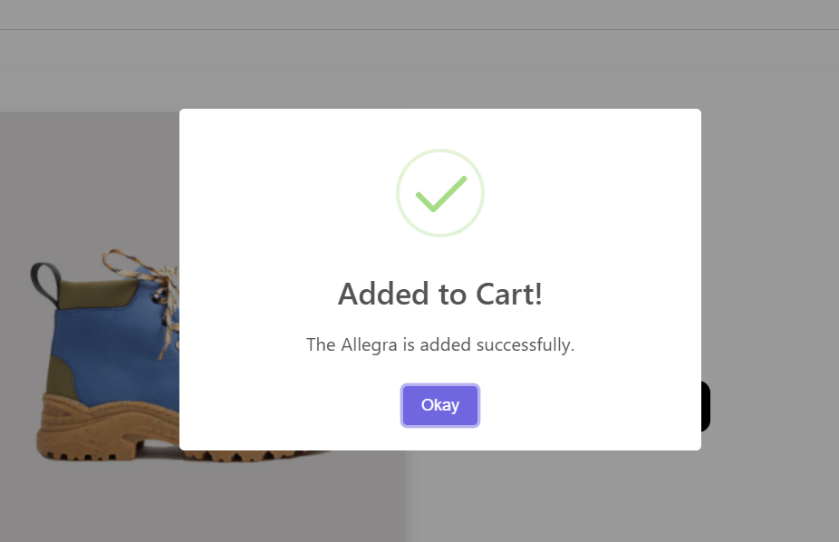

Conclusion:  
The website replication successfully recreates the visual design, layout patterns, and interactive elements of ThesusOutdoors.com using modern front-end technologies. The project demonstrates proficiency in responsive UI development, grid-based product presentation, branded styling, and jQuery-driven interactivity, achieving a clean, functional e-commerce interface suitable for academic evaluation.  
  
 X-----------------------------------------------------------------------------------------------X